Setting up an iPhone to connect to Office 365
- Tap Settings > Mail, Contacts, Calendars > Add Account.
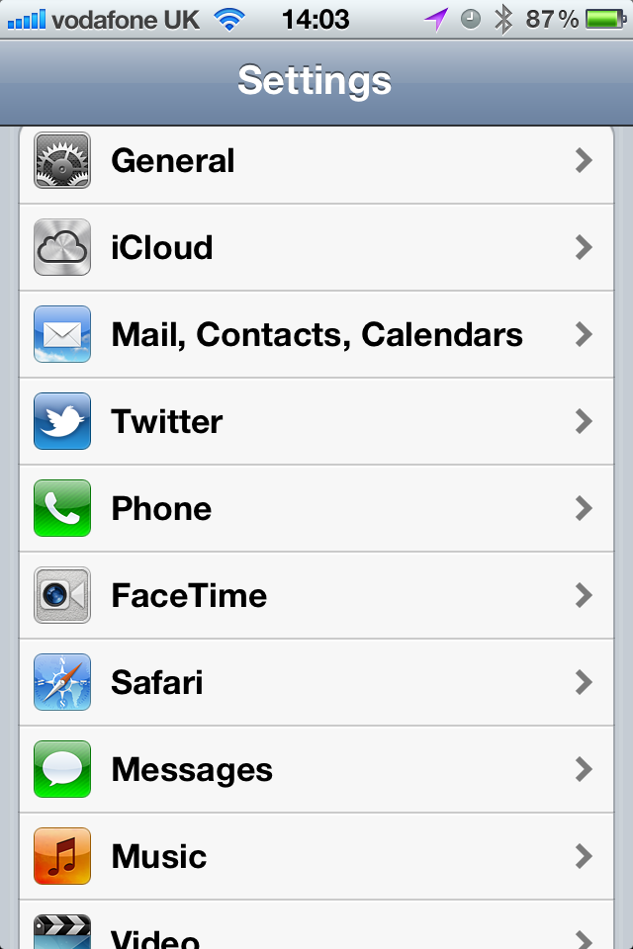
- Tap Add Account.
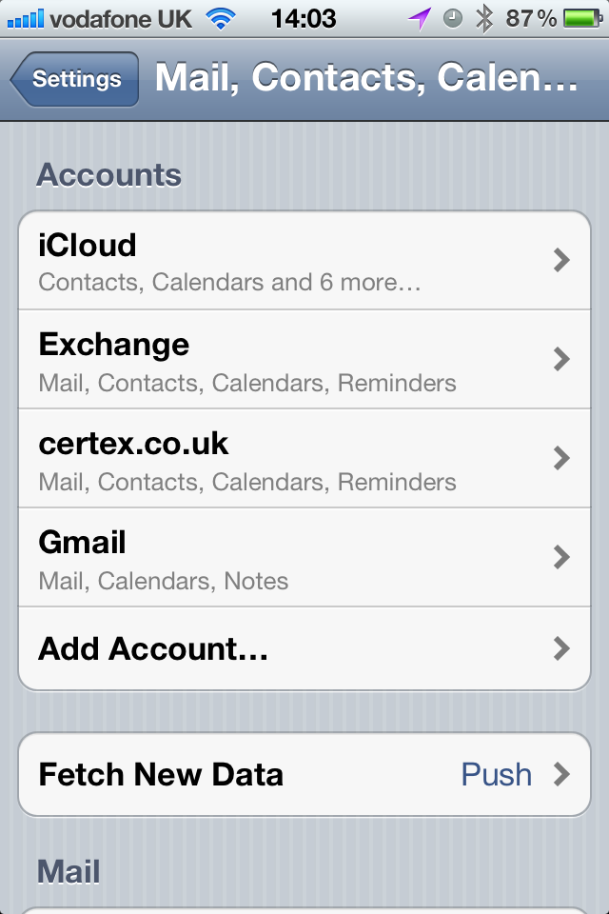
- Tap Microsoft Exchange.
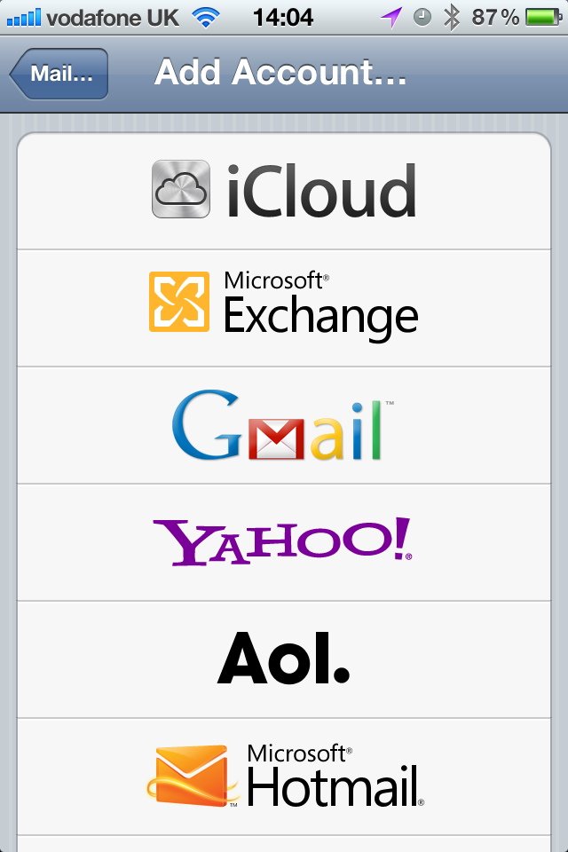
- You don’t need to enter anything in the Domain box. Enter the information requested in the Email, Username, and Password boxes. You need to enter your full e-mail address in the Email and Username boxes (for example, catherine.archer@torussupply.co.uk).
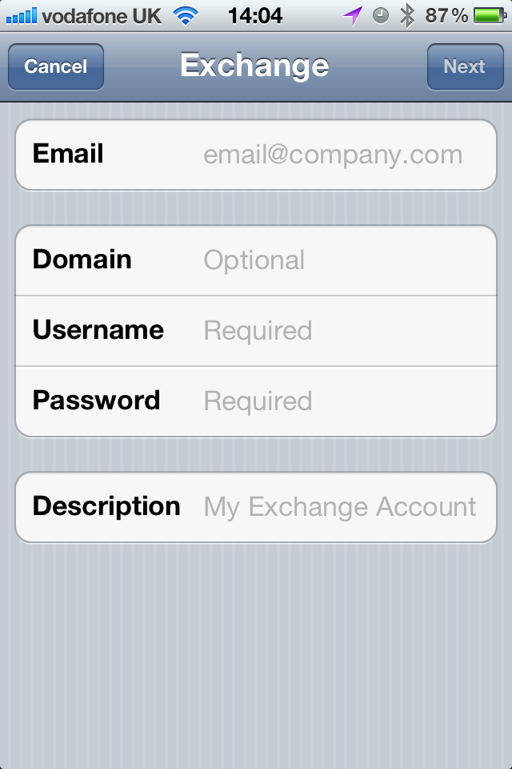
- Tap Next on the upper-right corner of the screen. Your iPhone will try to find the settings it needs to set up your account.
- You will probably get an error message saying it cannot automatically find the settings and you’ll then be returned to the settings screen where you can enter the server name.
- In the Server box, enter your server name which is m.outlook.com and then tap Next.
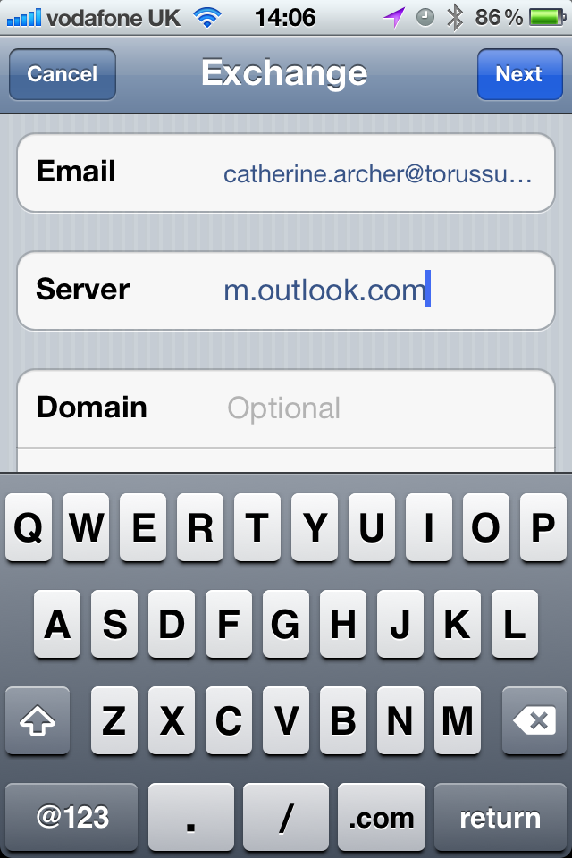
- Choose the type of information you want to synchronize between your account and your device, and then touch Save. By default, Mail, Contacts, and Calendar information are synchronized. You should then have an Exchange account set up.
Note: If you’re prompted to create a passcode, press “Continue” and enter a numeric passcode. If you don’t set up a passcode, you can’t use e-mail on your device. You can create a passcode later using Settings > General > Passcode Lock.

